**Lesson Notes**

1. What is the main purpose of an Operating System?
2. What is the difference between Operating System Software and Use Application Software?
3. What is the difference between Operating System Software and Computer Hardware?
4. What are the main parts of an Operating System?
5. What are some popular operating systems?

**Reference Diagram**

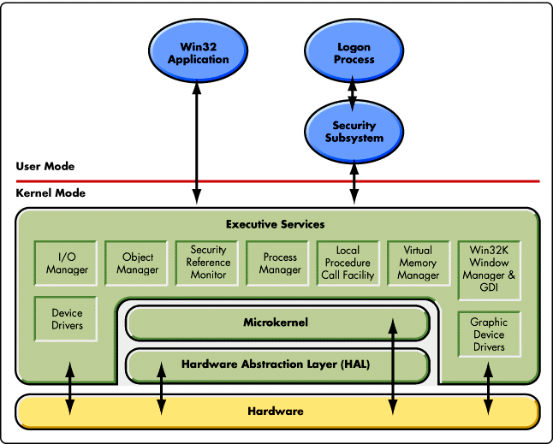

**Student Questions**

1. What is a device driver?
   1. Provide a brief summary
   2. List some devices that require a device driver.
   3. Provide a label on the reference diagram for the location of a device driver for your graphics card.
   4. Provide a label on the reference diagram for the location of a device driver for a locally attached printer.

A device driver is a software [program](https://searchsoftwarequality.techtarget.com/definition/program) that controls a particular type of hardware [device](https://whatis.techtarget.com/definition/device) that is attached to a computer. When buying an [operating system](https://whatis.techtarget.com/definition/operating-system-OS), many device drivers are built into the product. However, if a user later buys a new type of device that the operating system did not anticipate, the new device driver will have to be installed. A device driver essentially allows smooth communication between a connected hardware device and the operating system ([OS](https://whatis.techtarget.com/definition/operating-system-OS)).

Hardware that uses  a device driver to connect to a computer include printers, displays, [CD-ROM](https://whatis.techtarget.com/definition/CD-ROM) readers, network or sound cards, computer mice or [hard disks](https://searchstorage.techtarget.com/definition/hard-disk-drive). Device drivers will instruct a computer on how to communicate with each input/output ([I/O](https://whatis.techtarget.com/definition/input-output-I-O)) device through translating the operating system's I/O instructions to a software language the hardware device understands.

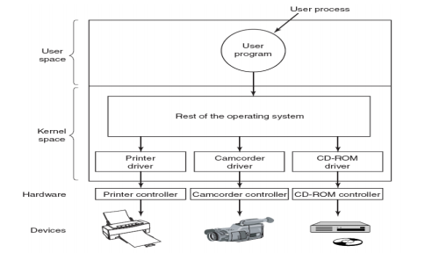

1. What is a DLL?
   1. Provide a brief summary
   2. Explain how DLLs are related to user application programs
   3. Provide a label on the reference diagram for the location of a DLL

A DLL file, short for Dynamic Link Library, is a type of [file](https://www.lifewire.com/what-is-a-file-2625878) that contains instructions that other programs can call upon to do certain things. This way, multiple programs can share the abilities programmed into a single file, and even do so simultaneously.

For example, several different programs might all call upon the veryuseful.dll file (I made that up, of course) to find the free space on a [hard drive](https://www.lifewire.com/what-is-a-hard-disk-drive-2618152), locate a file in a particular directory, and print a test page to the default printer.

Unlike executable programs, like those with the [EXE](https://www.lifewire.com/exe-file-2622732) file extension, DLL files can't be run directly but instead must be called upon by other code that is already running. However, DLLs are in the same format as EXEs and some may even use the .EXE file extension. While most Dynamic Link Libraries end in the [file extension](https://www.lifewire.com/what-is-a-file-extension-2625879) .DLL, others may use .OCX, .CPL, or .DRV.

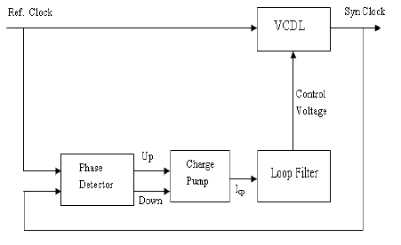

1. What is a windows manager?
   1. Provide a brief summary
   2. Explain how a windows manager is related to user application programs
   3. Provide a label on the reference diagram for the location of a windows manager

Generally, window managers work in collaboration with the desktop environment, logical graphical system and the underlying hardware to operate and manipulate graphical windows. These windows can be for the operating system or a software program/application. Some of the features window managers provide are the ability to minimize, maximize and close opened windows. The placement, effects, colors and transitioning may also be part of window managers, although this will depend on the underlying operating system, graphical libraries and system in use. Windows Explorer is a component in the Windows OS that incorporates and manages the window manager's tasks and features.

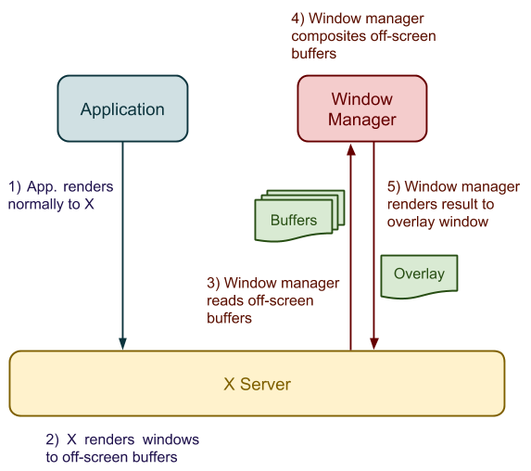

1. What is the windows task manager?
   1. Provide a brief summary
   2. List and explain four (4) types of system information provided by the task manager
   3. Provide a label on the reference diagram for the operating system components related to each type of information.

The Windows Task Manager is a powerful tool packed with useful information, from your system’s overall resource usage to detailed statistics about each process. This guide explains every feature and technical term in the Task Manager.

This article focuses on Windows 10’s Task Manager, although much of this also applies to Windows 7. Microsoft has dramatically improved the Task Manager since the release of Windows 7.